EXERCISE 1 -Martina Talevska

# TASK 1

* The WWW is widely used Internet service that is composed of resources and users on the internet that are using Hyper Text Transfer Protocol (HTTP) , also can be defined as collection of documents and services which are distributed across the Internet and linked together by hypertext links.
* Many home and small business users connect to the Internet via ***high-speed broadband Internet service***, which allows your computer or mobile device to be connected usually the entire time while it is powered on. Examples of broadband Internet service include cable, DSL, fiber, radio signals and satellite. Wireless Internet Service such as Wi-Fi networks, allows mobile users to connect easily to the Internet with notebook computers, smart phones and other mobile devices while away from a cable or other wired connections. Users access the web using a ***web browser*** such as Google Chrome, Safari, Mozila Firefox or Internet Explorer, to get to the Web documents called *webpages* that are linked to each other via hyperlinks. Technically, the information stored in websites is in web languages: HTML and JavaScript and the browser is acting as our translator and creates graphic interface for us. Actually the World Wide Web hinges on three enabling protocols, the ***HTML*** – HyperText Markup Language that specifies a simple markup language for describing hypertext pages, the ***HTTP***- HyperText Transfer Protocol which is used by web browsers to communicate with web clients, and ***URL*** – Uniform Resource Locators which is used to specify the links between documents.
* Web content is the *textual, aural* or *visual* content shown on the website.e.g. Image, video, Audio and Graphics. Depends on what are you are trying to reach with the content or what are you looking for in a content, it can be divided in four purposes:
* To entertain
* To educate
* To persuade
* To convert

A variety of content types is ideal for reaching and connecting with users at different points.

* Blogging- most accessible type of content marketing
* Longform Content -Ultimate Guides are one of the best types
* Case Studies- in-depth examinations covering a specific scenario
* White Papers-offers solutions and data on particular subject
* Ebook – they must offer value
* Infographics – pack a ton of information into one image in a way that is visually interesting and easily digestible.
* Template & Checklist Download -actionable, great source that users will utilize repeatedly
* Video – dynamic, engaging and more users watch videos than reading text
* Websites I visit more often are:
* <https://www.toneitup.com/>
* <https://www.pinterest.com/>
* <https://www.goodreads.com/>
* <https://www.youtube.com>/
* HTTP vs. HTTPS

In order to share information on the Internet network administrators had to agree on a procedure for exchanging information and called it HyperText Transfer Protocol (HTTP).Once everyone knew how to exchange information, the knowledgeable administrators agreed upon a procedure to protect the information they exchanged. The protection and the most important difference between the two protocols relies on SSL Certificate to encrypt the online data. HTTPS is actually a HTTP with an additional security. Encryption means that the sender and recipient agree upon a "code" and translate their documents into random-looking character strings.The procedure for encrypting information and then exchanging it is called HyperText Transfer Protocol Secure (HTTPS).With **HTTPS** if anyone in between the sender and the recipient could open the message, they still could not understand it. Only the sender and the recipient, who know the "code," can decipher the message. But in addition to adding that extra layer of security, HTTPS is also secured via TLS (Transport Layer Security Protocol) that helps data integrity which helps prevent the transfer of data from being modified or corrupted and proves to users that they are communicating with the intendent website. The user can identify whether a site uses http or https by the web address. The very first part of the web address *(before the “www”)* indicates whether the site uses HTTP or HTTPS protocols.

* Website: <https://whatis.techtarget.com/>

# TASK 2

1. Search engines:
   * Google Search
   * Bing Search
   * Yahoo Search
   * Ask.com
   * DuckDuckGo
   * Wolframalpha

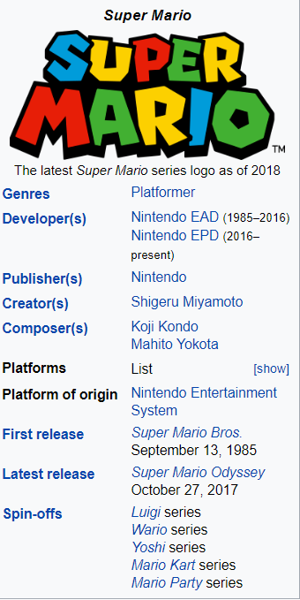

<https://mario.nintendo.com/>

<http://fromcusco.com/spheres/mp.html>

1. Map Service- 3D Tour

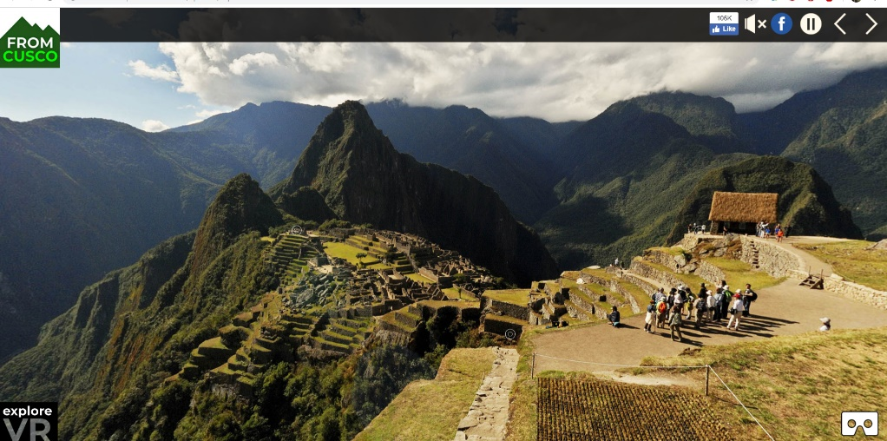

1. Online Translator

The largest pyramid in Giza is the Cheops River, which is 146 meters high. Thanks to the BBC and their 3D image, we have the opportunity to look at how this pyramid looks inside.In the pyramid there are hidden passages and rooms.  
The Great Pyramid in ancient times is considered one of the seven world wonders, and was built during the reign of Pharaoh Keps, between 2509 and 2483 BC.

What has been known to scientists and the public before is the existence of three large chambers, corridors and numerous passages. The most famous is the Great Gallery, which is 47 meters long and 8 meters high.Although there are entrances to the pyramid, much of its interior was unexplored until recently. Namely, French experts managed to penetrate the pyramid thanks to a mine-based detection method.

The 3D image of the BBC can see the interior of this pyramid, as well as the many hidden passages and rooms.

<https://www.fakulteti.mk/news/06102018/kako-izgleda-keopsovata-piramida-odnatre>

# TASK 3

1. Web browsers:

* Google Chrome -usually used
* Safari
* Mozila Firefox
* Opera
* Internet Explorer

1. Google Chrome/ HTML5 SupportTest



  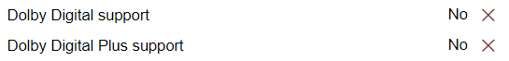

* **HTML**- Hyper Text Markup Language is the standard markup language used for creating web pages. *Hypertext* means that the document contains links that allow the reader to jump to other places in the document or to another document altogether. A *Markup Language* is a way that computers speak to each other to control how text is processed and presented. HTML elements are the building blocks of HTML pages. To do this HTML uses two things: tagsand attributes.
* **CSS –**Cascading Stylesheets

If HTML is used to create pages and make them functional,the code used to make them visually appealing is known as CSS. As the name suggest, you can have multiple CSS files or style blocks. The purpose of CSS is to provide Web developers with a standard way to define, apply and manage sets of style characteristics. There are three types of ways to define CSS:

* *Inline:* Style attribute directly on an HTML element. Typically, it is not recommended because it is difficult to define responsive styling this way.
* *Style blocks***:** Actually, is an HTML element, seen in the head section of the HTML file, but technically can be used anywhere in the HTML body as well. It is not recommended because it bloats the HTML file size, which increases the time before your page even starts to load.
* *External file:* it is linked to the HTML file in the head section. This is recommended approach for CSS.
* **JS-** JavaScript is the programming language of HTML and the Web, primarily to add automation, animations and interactivity to Web pages. Web developers use JavaScript for anything from automating simple tasks to creating complex Web Pages that behave like desktop software applications. JS is also used beyond the Web Software, servers and embedded hardware controls. Used in Web pages, JS is a “client-side” programming language. This means JavaScript scripts are read, interpreted and executed in the client, which is your Web Browser

# TASK 4

1. Every modern web browser includes a powerful suite of developer tools. These tools do a range of things, from inspecting currently-loaded HTML, CSS and JavaScript to showing which assets the page has requested and how long they took to load. Using Google Chrome which is based on the WebKit Web Inspector, it comes pre-installed in the Chrome browser. It's one the best general-purpose tools for development and debugging purposes.

* One great tool is the ability to right click on any element on a webpage and inspect the HTML for that element.
* Another useful tool is the CSS inspector; with this tool, you can check out which styles gets applied to an element and play with them yourself.
* These tools can both help you understand the structure of other websites and help you debug your own websites.

HTML

**CSS**

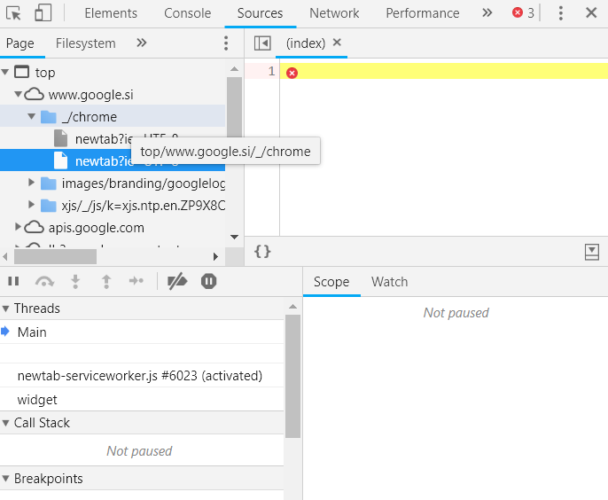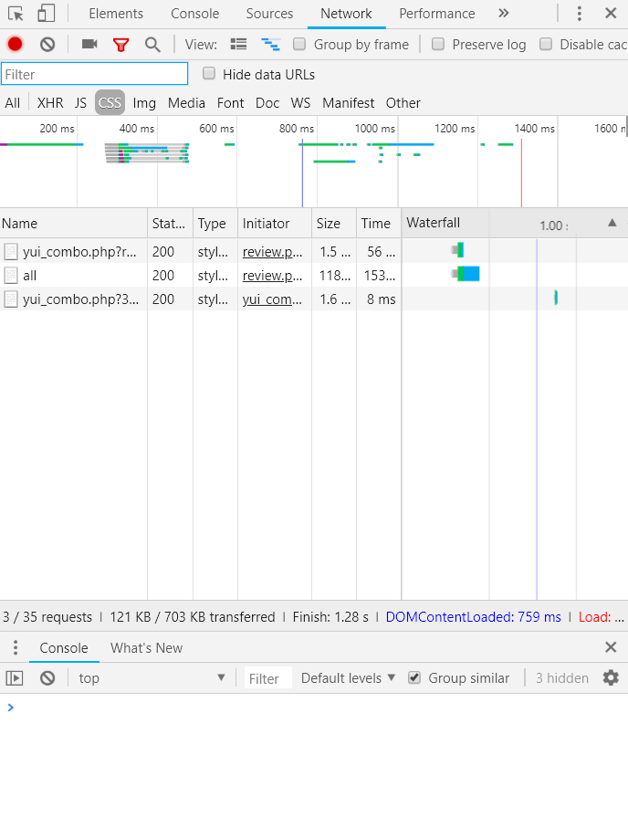

**HTTP**

# TASK 5

1. 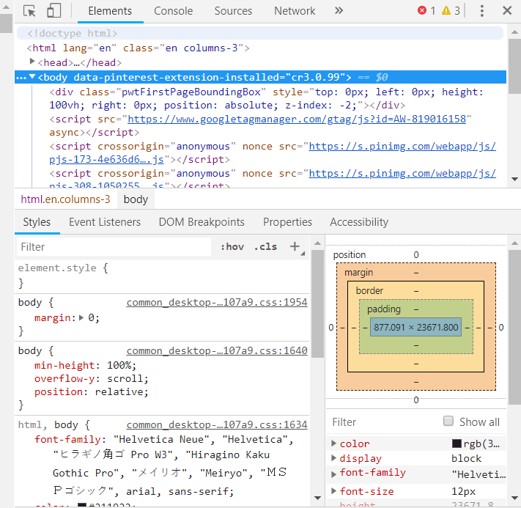A web server is a program that processes requests via HTTP, the basic network protocol used to distribute information on the World Wide Web also can be defines as a computer system that serves content using the HTTP protocol, and that’s why sometimes it is called an HTTP Server or Application Server. The term can refer to the entire system, or specifically to the software that accepts and supervises the HTTP requests. This content is frequently in the form of HTML documents, images and other web resources but also can include any type of file. Also nowadays, statistics show us that over 80% of web applications and websites are powered by open source web servers. The following is software which specifically processes web requests from end users:

* Apache HTTP Server - often referred to as httpd, or simply Apache powers 52% of all websites globally, and is by far the most popular web server.
* Apache Tomcat - Apache Tomcat is an open source Java servlet container that functions as a web server. A Java servlet is a Java program that extends the capabilities of a server.
* Node.js - Node.js is a server-side JavaScript environment for network applications such as web servers.

1. HTML -to create HTML Page.
2. CSS -to create good looking page.
3. Javascript -to perform client side function.

All of the above are Client Side Execution language. So, with all of them, we have need Server Side language which is going to perform generate dynamic content from files,Database, etc.

Here the few Dynamic Language which is used in Web Development.

1. Java (JSP,Servlet,JSF),
2. ASP.Net
3. PHP
4. Python
5. AngularJS
6. Ruby
7. .NET